**NNAMDI AZIKIWE UNIVERSITY, AWKA**

**DEPARTMENT: ELECTRONIC AND COMPUTER ENGINEERING**

**COURSE CODE: ECE 529**

**COURSE TITLE: SYSTEM PROGRAMMING**

**DESIGN AND IMPLEMENTATION OF A PROXIMITY BASED DOOR ACCESS CONTROL SYSTEM**

**BY**

**GROUP VIII**

**PARTICIPANTS’ REGISTRATION NUMBERS:**

**2011364012**

**2010364151**

**2011364091**

**2010364049**

**2010364209**

**2009364102**

**2010364214**

**2010364211**

**2009364112**

**2010364170**

**FEBRUARY, 2016**

**GROUP PARTICIPANTS**

|  |  |
| --- | --- |
| **NAMES** | **REG. NUMBERS** |
| ORIE CHINEDU EMMANUEL | 2011364012 |
| NWAOGBE GABRIEL C. | 2010364151 |
| OFORDUM BOBERT C. | 2011364091 |
| CHINYEAKA CHIEMELIE BLESSING | 2009364102 |
| AKUNWANNE CHINONSO M. | 2009364112 |
| EZENNAYA CHINEDU GEORGE | 2010364170 |
|  | 2010364209 |
|  | 2010364214 |
|  | 2010364211 |
|  | 2010364049 |

**PROXIMITY BASED DOOR ACCESS CONTROL SYSTEM**

The proximity based door access control system is a system which automatically controls the opening and closing of the door based on proximity of human beings.

The sensing unit is a passive infrared (PIR) sensor which detects human motion towards the door.

The control unit is AT89C51 microcontroller which collects the output from the sensor and activates the actuators that open or close the door through a dc motor.

The switching board consists of two relays connected in a manner that when one is energised at a time the motor rotates in either clockwise or anti-clockwise direction to facilitate the opening and closing of the door.

**BLOCK DIAGRAM OF THE PROXIMITY BASED DOOR ACCESS CONTROL SYSTEM**

Power supply unit

Proximity Sensor

(PIR sensor)

Microcontroller

Unit

Switchboard

(Relays)

Ready Indicator

Motor

(Door)

Power Supply Unit

Display Unit (LCD)

Microcontroller

Unit

Keypad

Switch Board (Relays)

Alarm Unit

Motor (Door)

Power Supply Unit

Display Unit (LCD)

Microcontroller

Unit

Keypad

Switch Board (Relays)

Alarm Unit

Motor (Door)

Power Supply Unit

Display Unit (LCD)

Microcontroller

Unit

Keypad

Switch Board (Relays)

Alarm Unit

Motor (Door)

Power Supply Unit

Display Unit (LCD)

Microcontroller

Unit

Keypad

Switch Board (Relays)

Alarm Unit

Motor (Door)

Power Supply Unit

Display Unit (LCD)

Microcontroller

Unit

Keypad

Switch Board (Relays)

Alarm Unit

Motor (Door)

Power Supply Unit

Display Unit (LCD)

Microcontroller

Unit

Keypad

Switch Board (Relays)

Alarm Unit

Motor (Door)

Power Supply Unit

Display Unit (LCD)

Microcontroller

Unit

Keypad

Switch Board (Relays)

Alarm Unit

Motor (Door)

Power Supply Unit

Display Unit (LCD)

Microcontroller

Unit

Keypad

Switch Board (Relays)

Alarm Unit

Motor (Door)

Power Supply Unit

Display Unit (LCD)

Microcontroller

Unit

Keypad

Switch Board (Relays)

Alarm Unit

Motor (Door)

Power Supply Unit

Display Unit (LCD)

Microcontroller

Unit

Keypad

Switch Board (Relays)

Alarm Unit

Motor (Door)

Power Supply Unit

Display Unit (LCD)

Microcontroller

Unit

Keypad

Switch Board (Relays)

Alarm Unit

Motor (Door)

Power Supply Unit

Display Unit (LCD)

Microcontroller

Unit

Keypad

Switch Board (Relays)

Alarm Unit

Motor (Door)

Power Supply Unit

Display Unit (LCD)

Microcontroller

Unit

Keypad

Switch Board (Relays)

Alarm Unit

Motor (Door)

**SCHEMATIC OF THE PROXIMITY BASED DOOR ACCESS CONTROL SYSTEM**

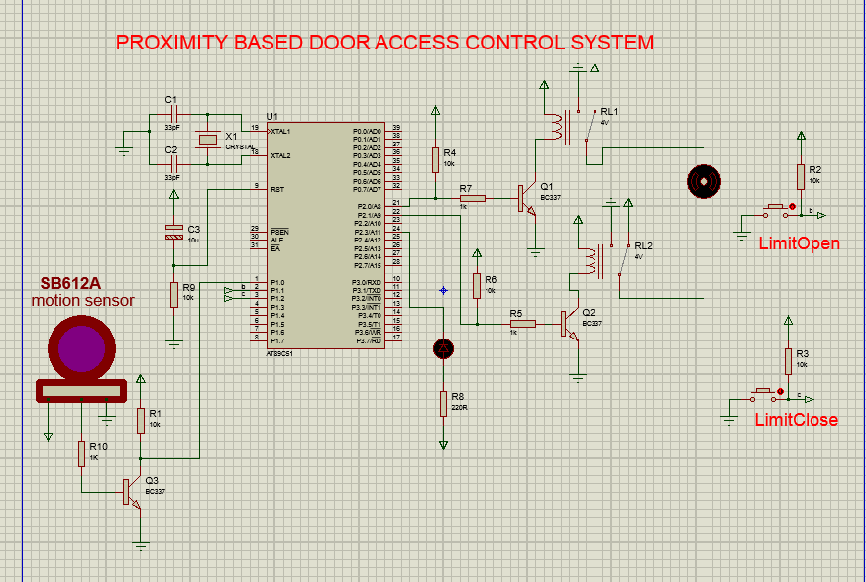

**PRINCIPLE OF OPERATION**

When the system is powered by toggling the Red switch, the system flashes light four times indicating that the system is ready. When a person approaches the door, the opening of the door is activated. The door continues opening until it hits the limit open switch. This is achieved by pressing the button on the left side of the door. The door opening is deactivated and the door waits for five seconds for the person to enter and thereafter the closing of the door is activated. The closing continues until it hits the limit close switch which is achieved by pressing the button at the right side. The closing is deactivated and the light flashes four times again showing that it is ready for another person to enter and the process continues.

**THE PROGRAM FLOWCHART**

Yes

Initialize system

Flash get ready Light

Sense Human presence

Is presence detected?

Check Opening Limit

Open door

Is opening limit reached?

No

No

Yes

A

B

**THE PROGRAM FLOWCHART CONTINUED**

A

Wait for entry

Close door

Check closing limit

Is closing limit reached?

Stop closing door

B

No

Yes

**THE PROGRAM CODE**

org 00h

sens bit p1.0

limit_open bit p1.1

limit_close bit p1.2

open bit p2.0

close bit p2.1

mov p1, #0ffh

mov p2, #00h

setb p2.3

;End of initialization

start:

;flash get ready light

mov r0,#4

here:

clr p2.3

call delays

setb p2.3

call delays

djnz r0,here

sense: jb sens,sense

call delay

setb open

LimitOpen: jb limit_open,LimitOpen

call delay

clr open

call delay_1s

setb close

stop: jb limit_close,stop

call delay

clr close

jmp start

delay_1s:

PET:Mov R1,#251

Mov R2,#51

Mov R3,#16

MEG: Djnz R1,MEG

Djnz R2,MEG

Djnz R3,MEG

Ret

delay:

PET1: Mov R1,#22

Mov R2,#134

Mov R3,#2

MEG1: Djnz R1,MEG1

Djnz R2,MEG1

Djnz R3,MEG1

Ret

delays:

PET2: Mov R1,#189

Mov R2,#205

Mov R3,#4

MEG2: Djnz R1,MEG2

Djnz R2,MEG2

Djnz R3,MEG2

Ret

end

**BILL OF ENGINEERING MEASUREMENT AND EVALUATION (BEME)**

|  |  |  |  |  |  |
| --- | --- | --- | --- | --- | --- |
| **S/N** | **COMPONENT/**  **MATERIAL** | **RATINGS** | **QUANTITY** | **UNIT PRICE**  **(NAIRA)** | **QUANTITY**  **PRICE**  **(NAIRA)** |
| 1 | AT89C51 |  | 1 | 300 | 300 |
| 2 | Crystal oscillator | 12MHz | 2 | 50 | 100 |
| 3 | Transformer | 12V,500mA | 1 | 400 | 400 |
| 4 | Bridge Rectifier | 1N4007 | 2 | 50 | 100 |
| 5 | Capacitor | 1000uF,25V  0.33uF  0.1uF  33pF | 2  2  2  4 | 40  20  20  10 | 80  40  40  40 |
| 6 | SB612A PIR Sensor | 3.3V Output | 1 | 1500 | 1500 |
| 7 | Regulator | LM7805 | 2 | 50 | 100 |
| 8 | IC socket | 40 pins | 2 | 30 | 60 |
| 9 | Transistor | BC337 | 6 | 20 | 120 |
| 10 | Limit Switch | SPST | 2 | 100 | 200 |
| 11 | Relay | 6V,10A | 2 | 80 | 160 |
| 12 | Diode | 1N4007 | 5 | 10 | 50 |
| 13 | Power switch | SPST | 1 | 50 | 50 |
| 14 | LED | 2.6V,10mA | 4 | 10 | 40 |
| 15 | Veroboard |  | 2 | 120 | 240 |
| 16 | Resistor | 1Kilohm | 10 | 5 | 50 |
| 17 | Resistor | 10Kilohms | 10 | 5 | 50 |
| 18 | DVD chamber |  | 1 | 1000 | 1000 |
| 19 | Packaging |  |  | 2500 | 2500 |
| 20 | AC plug |  | 1 | 100 | 100 |
| 21 | Transport |  |  |  | 1000 |
| 22 | Connector wire |  | 2 | 80 | 160 |
| 23 | Jumper wire |  | 1 yard | 50 | 50 |
| 24 | Fuel |  |  |  | 500 |
| 25 | Miscellaneous |  |  |  | 1500 |
|  |  |  |  |  |  |

**GRAND TOTAL = N9580**